UDC 111.222:333.44:555.66.77
N. N. Ivanov^{1*}, S. S. Petrov², P. P. Sydorov¹
¹Oles Honchar Dnipropetrovsk National University, Dnipropetrovsk, Ukraine
²W. Trzebiatowski Institute of Low Temperature and Structure Research, Polish Academy of Sciences, Wrocław, Poland
*e-mail: corresponding_author@server.ua
THE TITLE OF YOUR PAPER IN “VÌSNIK DNÌPROPETROVS’KOGO UNÌVERSITETU. SERÌÂ FÌZIKA, RADÌOELEKTRONIKA”
An abstract is composed of 200 – 250 words in Times New Roman Font with the 9th size. The abstract should be written in the Present Indefinite Tense or in the Past Indefinite Tense. Authors should avoid using the Present Perfect Tense at all, please. Authors should keep the chosen Tense over the whole abstract. The sense of abstracts in English, Ukrainian and Russian should be absolutely identical with keeping the same Tense style. The abstract should present the clear descriptions of the used models, the main results of the performed investigations, the interpretation of results and/or assumptions made on the basis of the results. The abstract should not contain the description of general physical problems or topicality of the investigations, or something like this. All of this must be presented in the Introduction. All the three-language abstracts should be placed in the first page of the paper completely. Please, choose the proper style in order to satisfy this requirement. If possible, avoid long complicated sentences. Please, simply insert or print your text instead of this instruction.
Keywords: the use of about five precise typical words or their combinations divided by commas is preferable.
Реферат складається з 200 – 250 слів, надрукованих шрифтом Times New Roman із 9-м розміром кегля. Реферат має бути написаний у теперішньому або в минулому часі. Будь ласка, уникайте вживання в англійському тексті Present Perfect Tense. Дотримуйтесь обраного стилю викладання стосовно часу протягом усього реферату. Зміст рефератів англійською, українською та російською мовами має бути абсолютно ідентичним із збереженням однакового стилю викладу. У рефераті подаються чіткі описи використаних моделей, основних результатів виконаних досліджень, інтерпретація результатів та/або припущення, зроблені на підставі цих результатів. Реферат не повинен містити опису загальних фізичних проблем і актуальності досліджень або чогось подібного до цього. Все це має бути представлено у Вступі. Реферати, подані всіма трьома мовами, мають розміститись на одній першій сторінці Вашої статті. Оберіть, будь ласка, відповідний стиль викладу, щоб задовольнити цій вимозі. По можливості уникайте довгих складних речень. Будь ласка, просто розмістіть або надрукуйте Ваш текст замість цієї інструкції.
Ключові слова: найкращим є використання близько п’яти точних типових слів або словосполучень, розділених комами.
Реферат состоит из 200 – 250 слов, напечатанных шрифтом Times New Roman с 9-м размером кегля. Реферат следует писать в настоящем или прошедшем времени. Пожалуйста, избегайте использования в английском тексте Present Perfect Tense. Придерживайтесь выбранного стиля изложения касательно времени во всем реферате. Смысл рефератов на английском, украинском и русском языках должен быть абсолютно идентичен с сохранением единого стиля изложения. В реферате четко описываются использованные модели, основные результаты выполненных исследований, интерпретация результатов и/или предположения, сделанные на основе этих результатов. Реферат не должен содержать описания общих физических проблем и актуальности исследований или чего-то подобного. Все это должно быть представлено во Введении. Рефераты, написанные на всех трех языках, должны уместиться на одной первой странице Вашей статьи. Пожалуйста, выберите соответствующий стиль изложения, чтобы удовлетворить этому требованию. По возможности избегайте длинных сложных предложений. Пожалуйста, просто разместите или наберите Ваш текст вместо этой инструкции.
Ключевые слова: предпочтительным является использование около пяти точных типичных слов или словосочетаний, разделенных запятыми.©
1. Introduction
Please, insert your text into this template leaving all formatting as it is.
The text font of the main body of your paper is Times New Roman, size 11. Each new paragraph should be started with an indentation of 0.8 cm. The space between lines of the main text is single.
Present your abbreviations in the brackets at their first mention in the text after the full definition, e.g. “… filled with 2,5-bis(2-benzoxazolyl)hydroquinone (BBHQ) …”. Ensure consistency of abbreviations throughout the paper. Avoid using abbreviations in the abstract.
Each Section of your paper must be numerated. The title of the Section should precisely reflect its contents.
The Section of “Acknowledgments” may appear by the end of your paper before the “References” Section, if needed. The Sections titled “Acknowledgments” and “References” are not numerated.
Please, if possible, make your references to the latest existent publications in the field you study. It sharpens the novelty of your paper.
The references are numbered in the order of their appearance in the text (not alphabetically) in the square brackets. The samples of the references for papers [1-3], books [4, 5], conference proceedings and abstracts [6, 7] are presented below.
All references data must be in English. Use the transliteration rules when reproducing the title of journal, published in non-English only [1].
For the authors who refer to papers published in journals, translated into English by foreign publishing houses, the Editorial Board recommends to present these references as they appear in the English edition [2].
Follow internationally accepted rules and conventions: use the international system of units (SI). If other units are mentioned, please give their equivalent in SI.
2. The presentation of the formulae
Present simple formulae in the line of normal text where possible and use the solidus (/) instead of a horizontal line for small fractional terms, e.g. X/Y.
The Greece variables must be presented as usual, i.e. non-italic, e.g. γ, π, φ, χ, θ. The Latin variables must be italicized, e.g. g, p, f, x, t. Vectors are presented with bold, non-italic letters or symbols, e.g. G, P, g, p. Please, keep these rules during the whole paper, especially, in the axis captions in the figures.
Present more complex formulae in the Microsoft Equation Editor 3.0. The use of the other Editor may strongly complicate the work and result in delaying your paper.
The variables in the main line of your formula are typed by Times New Roman 11. The font of subscripts and superscripts is Times New Roman 7. The minimal possible size of sub-subscripts and super-superscripts is Times New Roman 5.
Number consecutively any equations that have to be displayed separately from the text. The equations must be centered.
In order to make this procedure easier, the equation and its number are offered to be put into the Table with hidden borders like that presented in Eq. (1) and the set (2)
$W=\frac{1}{2}\int{E⋅D\text{dV}}$, | (1)
$$W=\begin{aligned}\left\{\frac{1}{2{πlε}_{1}}\frac{Q}{r}\text{ at }r_{1}<r<a, | \right.\left\{\frac{1}{2{πlε}_{2}}\frac{Q}{r}\text{ at }a<r<r_{2}, | \right.\end{aligned}$$ | (2)
where a space between expression and main text is already fixed by 6 pts on both sides.
When dividing your formula from the plain text, place comma or point outside the framework of your whole expression. Do not use comma after the expression before “where” when the symbols definition is given. Please, do not finish the Sections of your paper with “bare” formula without analyzing or discussing it.
3. The presentation of the figures
Figures may be inserted into the text as soon as mentioned or gathered at the end of the paper. All of them should be numbered with consecutive Arabic numbers, have descriptive captions and be refereed to in the text.
White-black figures are prepared in a readable computer form; with the resolution not less than 600 dpi (TIFF format is preferable) and the width no larger than 14 cm.
The axes are captioned by the text or the mentioned symbols which are followed by the corresponding units divided by comma. All captions and designations inside the figure should be made in Times New Roman.
The figure caption is typed by a centered bold Times New Roman 9 font and placed just after the figure. The sample of the possible figure presentation is given in Fig.1.
In case of using Microcal Origin 7.0 for preparing figures the authors may additionally submit the figures in files with this Editor format.
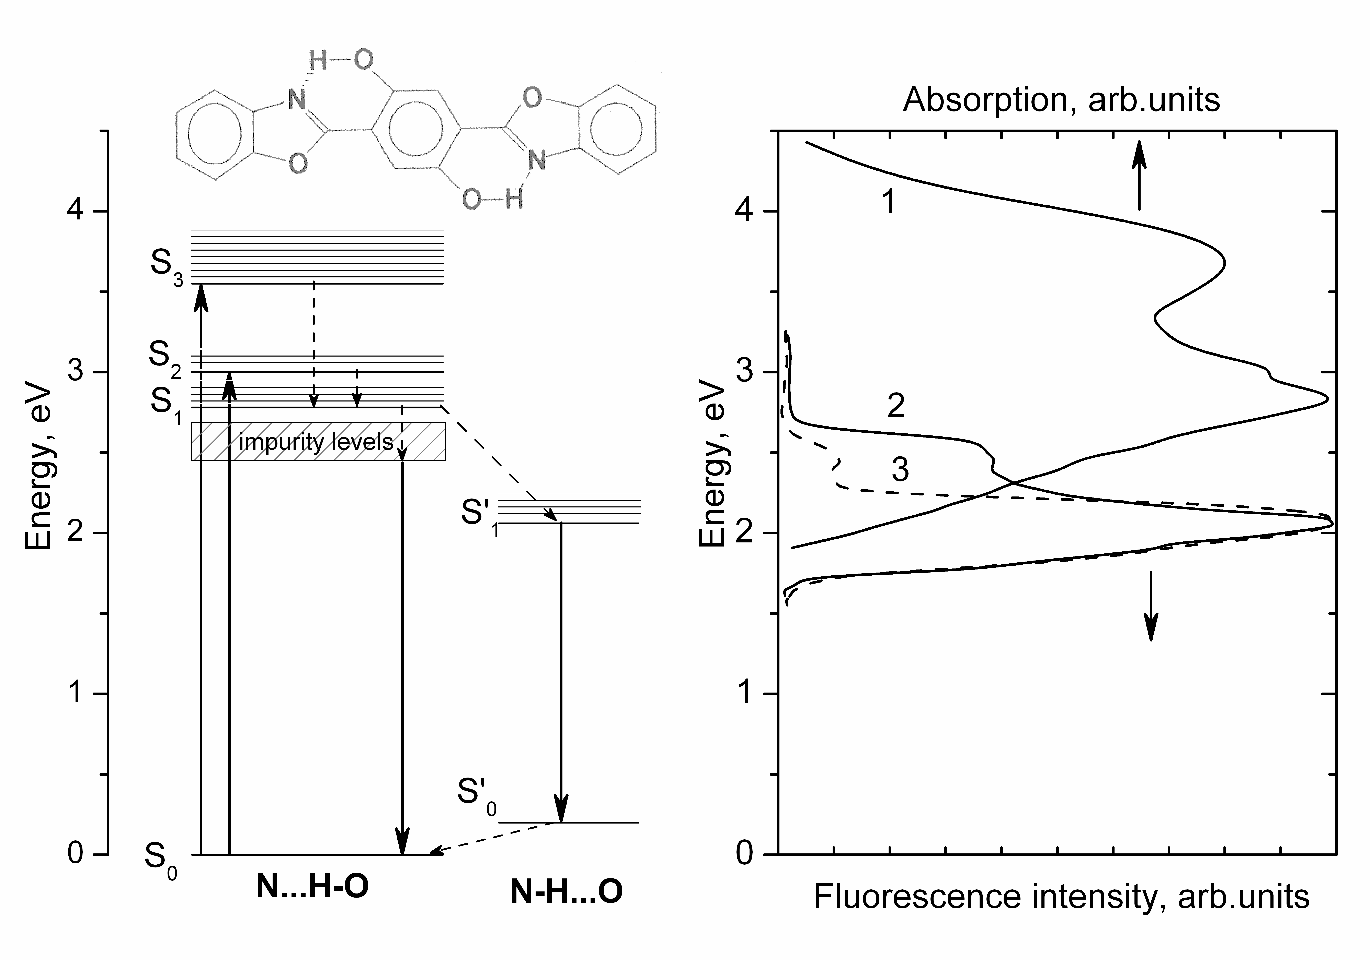
(a) (b)
Fig. 1. The structural formula of BBHQ molecule and the energy diagram of its electronic states in the solid phase state with indicating possible transitions (a). The energy diagram was built on the basis of the measured absorption (1) and fluorescence (2, 3) spectra of polycrystalline BBHQ (b). The ground state of an enol BBHQ structure is taken for the zero - energy level. The dashed arrows correspond to the non-radiative transitions. The fluorescence was excited by a 337 nm nitrogen laser radiation.
4. The presentation of the tables
Insert tables into the text as soon as mentioned or gather them at the end of the paper. Number tables consecutively with Arabic numbers and give each a clear descriptive caption at the top. The tables must be centered.
Use the Times New Roman 9 font. It should be italic when you number the tables, be centered and bold in the caption and be usual, when you fill in the table.
When inserting into the table the variables or symbols prepared in the Microsoft Equation Editor 3.0, please, format they in a proper way. The variables in the main line of your formula should be typed by Times New Roman 9. The size of subscripts and superscripts must be 5 or 6.
The samples of the possible table presentation are given in Tables 1, 2.
Table 1
The results of optimization of the weight function to select $a^{2}>$ for LEP energies. The parameter $k={c_{2}}/{c_{1}}$ is computed in accordance with (9), the coefficients $c_{i}$ in (13) are found by (7)
$\sqrt{s}$, GeV | k | $$с_{1}$$ | $$с_{2}$$ | $$с_{3}$$ | $$с_{4}$$ | $$с_{5}$$ | $$с_{6}$$ | $$с_{7}$$ | $$с_{8}$$
130 | -0.567 | 0.770 | -0.437 | -0.416 | 0.193 | -0.011 | -0.050 | -0.044 | 0.019
136 | -0.524 | 0.802 | -0.420 | -0.392 | 0.141 | 0.025 | -0.061 | -0.040 | 0.014
161 | -0.425 | 0.863 | -0.367 | -0.330 | 0.036 | 0.076 | -0.056 | -0.017 | 0.000
172 | -0.402 | 0.876 | -0.352 | -0.314 | 0.014 | 0.083 | -0.052 | -0.011 | -0.003
183 | -0.385 | 0.885 | -0.340 | -0.302 | -0.002 | 0.086 | -0.048 | -0.007 | -0.004

Table 2
Phase composition, coherent scattering areas (L), the degree of distortion of the crystal lattice (Δa/a), microhardness (H_{μ}) and the dislocation density (ρ) of the investigated alloys
Alloy | Phase composition | L, nm | Δa/a | H_{μ}, MPa | H_{μ}, MPa (after heat treatment) | ρ, cm⁻²
CoCrCuFeNiSn_{0.5} | FCC (а = 0.3586 nm) + BCC (CsCl-type,  а = 0.2979 nm) | L_{FCC} = 37 ± 2  L_{BCC} = 27 ± 2 | 1.8·10⁻³ | 3500 ± 200 | 3800 ± 200 | 4.2·10¹¹
CoCrCuFeNiSn₁ | FCC (а = 0.3600 nm) + BCC (CsCl-type,  а = 0.2981 nm) | L_{FCC} = 19 ± 2  L_{BCC} = 21 ± 2 | 2.3·10⁻³ | 4000 ± 200 | 3900 ± 200 | 1.6·10¹²
5. Conclusions
Present enhanced conclusions of your work. Please, avoid giving absolutely equal text in the conclusions and in the abstract.
Acknowledgments
We would like to thank you for your attention and following this template. We would be very thankful to you for proposals and advices to improve our collective work.
References
1. Moiseyenko, V. N. Spontannoye parametricheskoye rasseyaniye sveta v prostranstvenno-neodnorodnykh nelineynykh sredakh na osnove fotonnykh kristallov [Text] / V. N. Moiseyenko, M. P. Dergachov, V. G. Shvachich // Optika i Spektroskopiya. – 2012. – Vol. 112, No. 2. – P. 223 – 225.
2. Moiseyenko, V. N. Spontaneous parametric light scattering in spatially inhomogeneous nonlinear media based on photonic crystals [Text] / V. N. Moiseyenko, M. P. Dergachov, V. G. Shvachich // Optics and Spectroscopy. – 2012. – Vol. 112, No. 2. – P. 198 – 200. – ISSN 0030-400X.
3. Gulov, A. V. Optimal one-parameter observables for Z' searches in $e^{+}e^{−}→μ^{+}μ^{−}$ process [Text] / A. V. Gulov // e-print arXiv: 1308.4837v1 [hep-ph].
4. Martin, P.M. Handbook of deposition technologies for films and coatings 3rd edition [Text] / P. M. Martin. – 3rd edition. – Amsterdam: Elsevier, 2010. – 912 p.
5. Mukhopadhyay, N. K. Alloys Compounds [Text] / N. K. Mukhopadhyay, G. V. S. Murthy, B. S. Weatherly. – Singapore: World Scientific, 2002. – 206 p.
6. Andreev, M. V. Determination of Parameters of Fractional-Rational Model Using Interpolation by Continued Fraction [Text] / M. V. Andreev, V. F. Borulko, O. O. Drobakhin, D. Yu. Saltykov // Conference Proceedings of the Intern. Conf. on Mathematical Methods in Electromagnetic Theory. – London, 2006. – P. 264 – 266.
7. Moiseyenko, V.N. Creation and investigation of optical properties of nanocomposites on the base of synthetic opals and active dielectrics [Text] / V. N. Moiseyenko, M. P. Dergachov, A. V. Yevchik, G. I. Dovbeshko // International research and practice conference “Nanotechnology and nanomaterials (NANO-2013)”. Abstact book. – Bukovel, Ukraine, 25 August – 1 September 2013. – P. 143.
Received 15.03.2015

 N. N. Ivanov, S. S. Petrov, P. P. Sydorov, 2016

